2.1
Before defining the architecture, we identify the architectural drivers: the requirements and quality attributes that most strongly shape the design. The assignment explicitly says these drivers must be ranked, and that different rankings should lead to different architectures. This means the ranking cannot be decorative; it must clearly affect how responsibilities are split, which services are isolated, and how the system behaves under failure.For this system, the most important drivers come from the fact that the product is not just a text editor but a real-time collaborative editor with integrated AI assistance

Ranked architectural drivers

1. Real-time collaboration responsiveness and consistency
Real-time collaboration is the primary driver because the core user experience depends on fast, consistent shared editing with low latency. This leads to separating the real-time synchronization layer from normal document operations and AI workflows, ensuring that live typing, cursor updates, and presence remain responsive and are not affected by slower request-response or AI processing.

2. AI integration as a core product feature, but safely reviewable
AI is designed as a core feature, but all outputs must be reviewed and approved by the user before being applied. This drives a design where AI is isolated into its own service that handles prompt construction, model selection, quotas, and logging, and returns suggestions that users can accept, reject, or modify instead of directly changing document content.

3. Availability and graceful degradation
The system must remain usable even when parts fail, meaning editing should continue if AI is unavailable and solo editing should still work if real-time sync fails. This leads to isolating major services (real-time, AI, and storage) so failures do not cascade, allowing the system to degrade gracefully instead of becoming completely unusable.

4. Authentication, authorization, and privacy
Security is a cross-cutting concern because documents are shared and may contain sensitive content. The architecture therefore enforces authentication and role-based authorization across both API and real-time layers, and ensures that AI usage respects permissions and privacy constraints when interacting with external providers.

5. Versioning, auditability, and document lifecycle
The system must support document history, version restoration, and traceability of changes, including AI-assisted edits. This drives a storage design that persists document metadata, versions, permissions, and AI interaction logs rather than only the latest state.

6. Scalability and growth
The system must handle many concurrent users and documents while scaling over time. This encourages stateless services, horizontally scalable real-time infrastructure, and asynchronous processing (e.g., queued AI requests) so that increased load does not degrade performance.

2.2 System Design using the C4 Model

Level 1 — System Context Diagram
At the context level, the platform is treated as a single system. The main external actors are collaborators, document owners/team leads, and organization administrators, reflecting the assignment’s emphasis on multiple roles and access-control scenarios. External systems include an identity provider, third-party LLM APIs, a notification service, and an export service. This keeps the diagram product-level and stakeholder-friendly
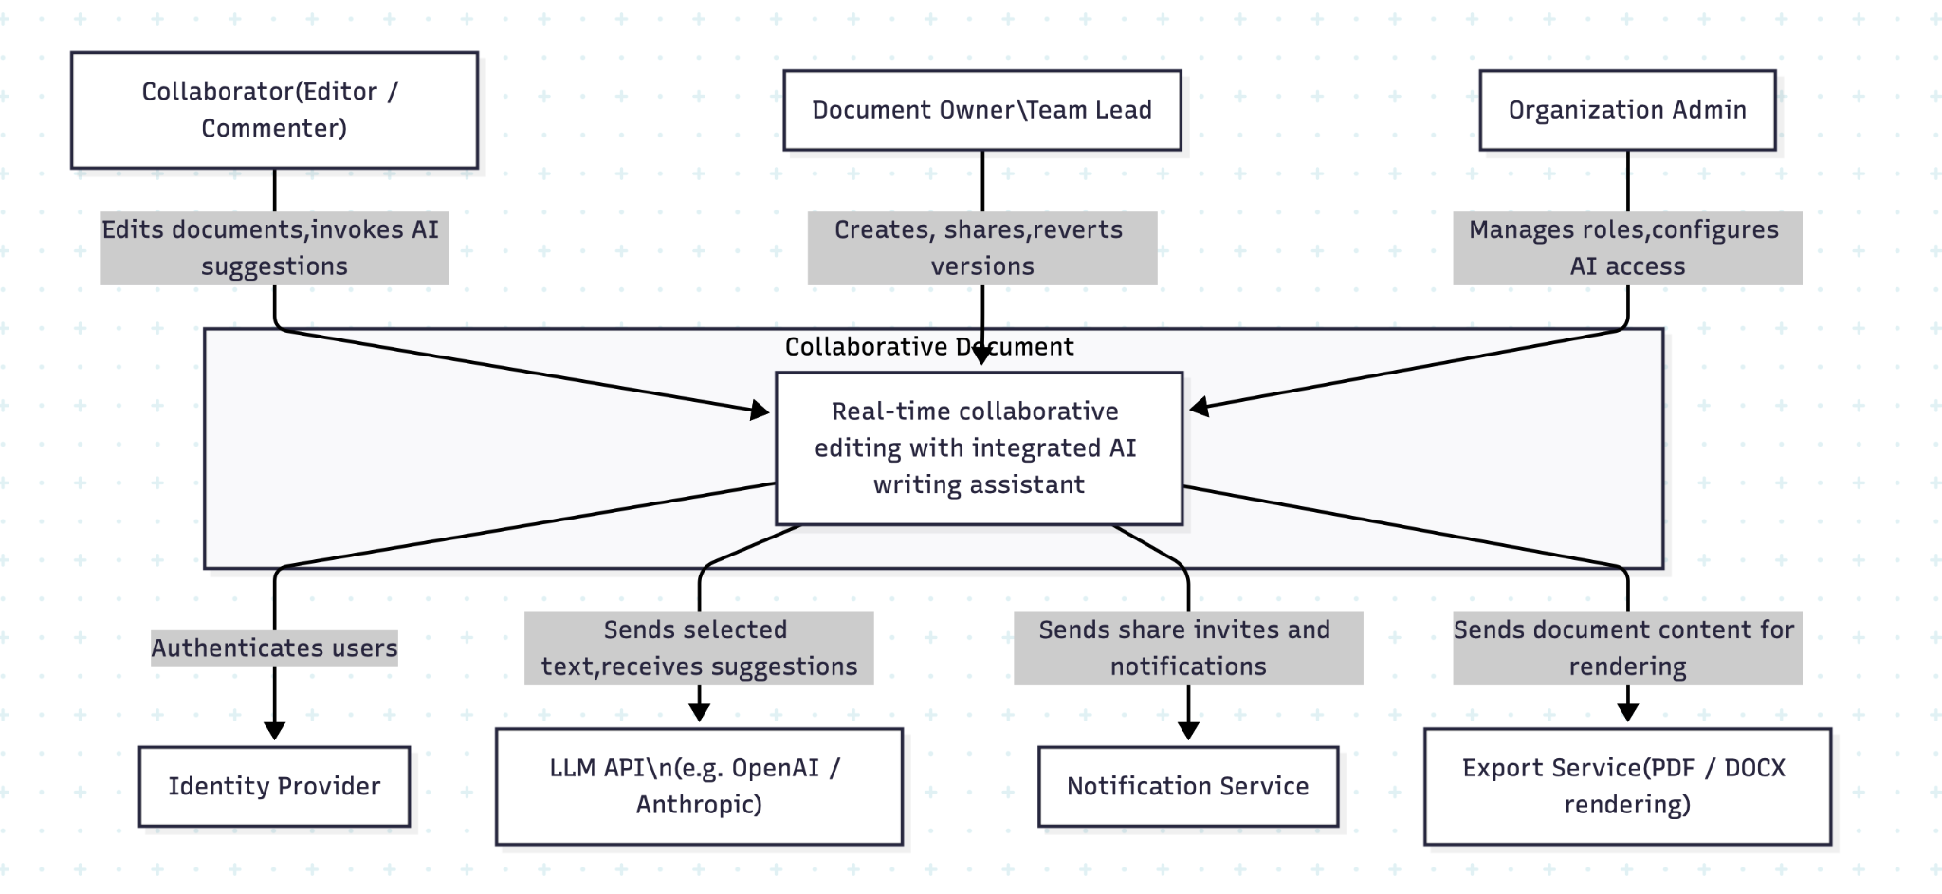
Level 2 — Container Diagram
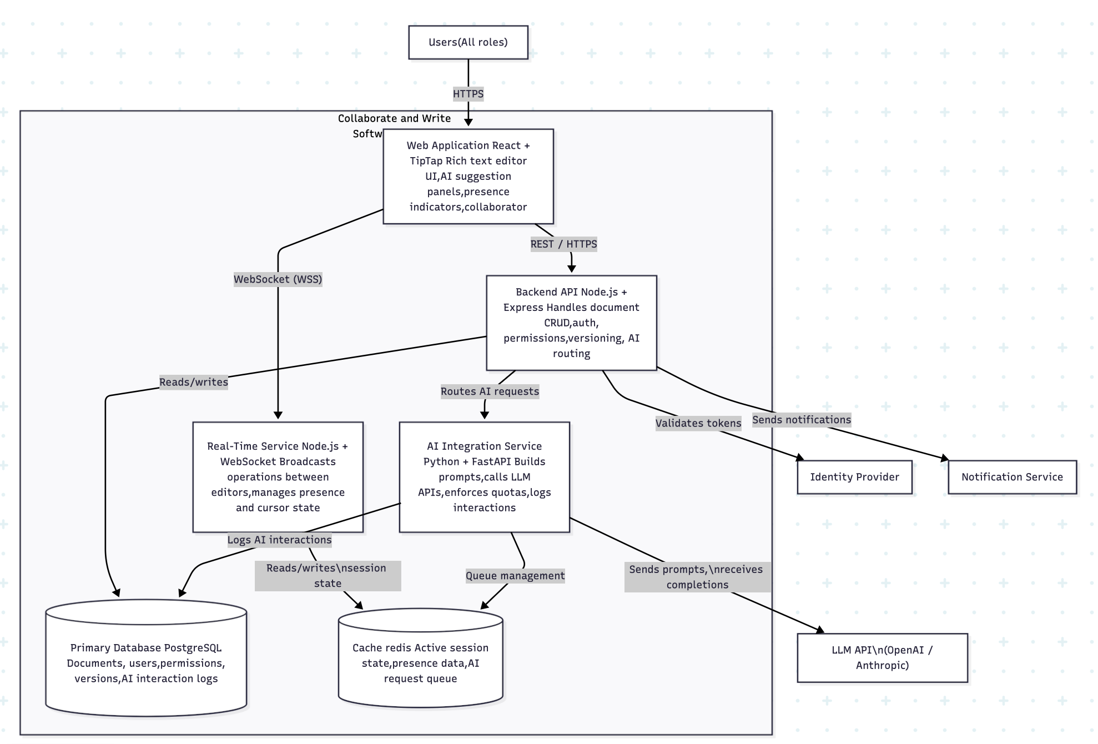
This diagram opens the black box from Level 1 and shows the six major containers — the deployable, runnable pieces of the system. The frontend handles everything the user sees and touches. The real-time service is kept separate from the backend API deliberately: this is a direct consequence of Architectural Driver 1 — real-time operations (typing, cursor movement, presence) must never be slowed down by document saves, AI calls, or authentication checks. The backend API handles all request/response operations that can tolerate slightly higher latency. The AI integration service is its own container because of Driver 2 — it manages prompt engineering, model selection, quota enforcement, and logging, and it must be independently deployable so it can be scaled or swapped without touching the editor. PostgreSQL stores all persistent data. Redis serves two purposes: it holds ephemeral real-time state (who is online, where their cursor is) that doesn't need to survive a restart, and it acts as a queue for AI requests during traffic spikes.

Level 3 -Component Diagram (AI Integration Service)
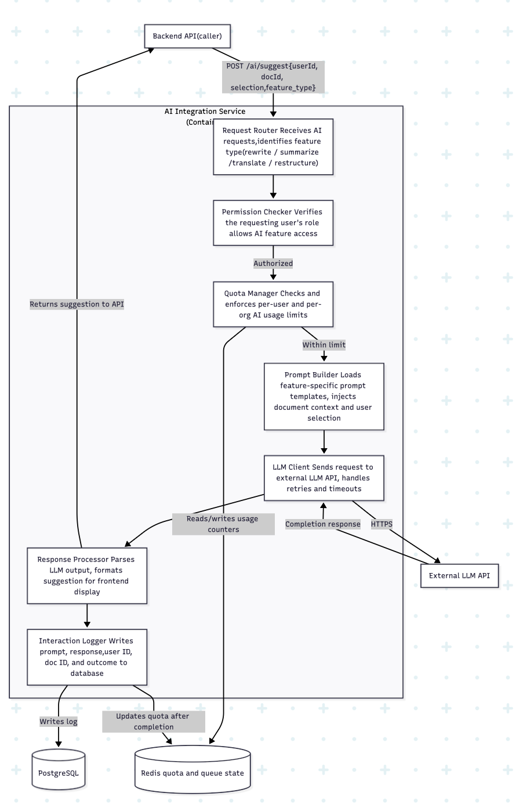This diagram zooms into the AI Integration Service and shows how a single AI request flows through seven internal components. The Request Router receives every AI call and identifies what type of feature is being invoked — this matters because rewrite, summarize, translate, and restructure each use different prompt templates. The Permission Checker runs before anything else to verify the user's role allows AI access — this enforces Driver 4 (authorization) at the service level, not just at the API gateway. The Quota Manager checks usage counters in Redis before calling the LLM, preventing runaway costs — this reflects Driver 2 (AI as a safely managed feature). The Prompt Builder loads the appropriate template and injects the user's selected text and surrounding context — this is where prompt logic lives, meaning prompts can be updated by changing template files without redeploying the service. The LLM Client handles the actual external API call including retries and timeouts. The Response Processor formats the raw LLM output into the structured suggestion object the frontend expects. The Interaction Logger records everything — what was sent, what came back, whether it was accepted — satisfying Driver 5 (auditability).
Feature Decomposition
The decomposition follows the architectural choices made in our design:
- a monorepo for coordinated development across frontend and backend,
- a modular monolith backend rather than microservices,
- a suggestion-based AI model rather than automatic AI edits,
- and append-only versioning for traceability and safe recovery.
This modular structure is intended to ensure that each part of the system can be developed, tested, and evolved with limited impact on unrelated parts.

Decomposition Overview
The system is divided into six primary modules:
- Rich-Text Editor and Frontend State Management
- Real-Time Synchronization Layer
- AI Assistant Service
- Document Storage and Versioning
- Authentication and Authorization
- API Layer Connecting Frontend and Backend
Rich-Text Editor and Frontend State Management
This module is responsible for the user-facing document editing experience. It renders the document, captures local edits, manages selection state, applies formatting actions, displays cursor and presence indicators, and integrates AI suggestion review into the editing workflow.
The editor must also support:
- selected-text AI operations,
- contextual AI toolbar behavior,
- conflict markers,
- collaborator cursors and presence,
- suggestion review and application,
- and recovery of local unsaved changes after reconnect.
This module therefore owns the interactive editing state of the document from the user’s perspective. That includes:
- current document content in memory,
- current selection range,
- undo/redo history on the client,
- local pending operations,
- collaborator UI state,
- active suggestion previews,
- and transient interface behavior such as loading, paused AI results, and conflict highlights.
This design aligns with the requirements that selected text can be sent to the AI assistant, suggestions must be reviewable before application, collaborators’ activity must be shown in the interface, and reconnecting users should recover the latest state or preserved local edits.

What it depends on
The rich-text editor depends on:
- Real-Time Synchronization Layer to send local edits and receive remote operations, cursor movement, and collaborator presence.
- API Layer to load initial document state, save explicit actions, request AI operations, fetch version history, and update sharing settings.
- Authentication and Authorization Module to determine whether the user can edit, comment, invoke AI, restore versions, or manage sharing.
- Document Storage and Versioning Module, indirectly through the API, to retrieve current content and historical data.
- AI Assistant Service, indirectly through the API, to request writing assistance and receive structured suggestion results.

What interface it exposes
The editor module exposes interfaces primarily to other frontend modules and the synchronization client. These are internal application contracts rather than public HTTP endpoints. Example exposed interfaces include:
- loadDocument(documentId)
- applyLocalOperation(operation)
- applyRemoteOperation(operation)
- onSelectionChange(range)
- openSuggestionPanel(suggestionPayload)
- acceptSuggestion(suggestionId, editedContent?)
- rejectSuggestion(suggestionId)
- showConflictRegion(conflictData)
- restoreRecoveredDraft(localDraft)
At the UI boundary, it also exposes clear events for surrounding modules:
- edit produced,
- selection changed,
- suggestion accepted/rejected,
- collaborator presence updated,
- reconnect recovery needed.
Separating the editor from networking and backend concerns improves maintainability. The editor should not directly know database structure, token parsing, or LLM provider details. Its responsibility is to manage the user’s editing experience and convert user actions into higher-level domain events. It also supports testing: editor behavior can be tested with mocked synchronization and mocked AI responses instead of requiring a running backend.

Real-Time Synchronization Layer
This module is responsible for keeping active collaborators in sync while they edit the same document. It propagates edits between users, updates collaborator presence and cursors, detects overlapping edit situations, supports reconnection recovery, and coordinates conflict handling behavior.
The synchronization layer handles:
- joining and leaving live document sessions,
- broadcasting editing operations,
- receiving remote operations,
- presence tracking,
- cursor and selection sharing,
- reconnect synchronization,
- basic conflict detection and forwarding conflict cases to the conflict-resolution workflow.
This directly supports the collaboration requirements for simultaneous editing, live synchronization, conflict detection, conflict resolution, and reconnection/session recovery.
The synchronization layer depends on:
- Rich-Text Editor Module for local edit events and application of remote operations.
- Authentication and Authorization Module to verify that a user may join a document session and perform editing actions.
- API Layer / Realtime Session Endpoints for session bootstrap, token validation, and possibly fallback synchronization.
- Document Storage and Versioning Module for loading authoritative state during reconnect or recovery.
- Conflict Resolution Logic, which may involve the AI Assistant Service when AI-assisted merge proposals are requested by users.

What interface it exposes
The synchronization layer exposes a session-oriented interface such as:
- connect(documentId, sessionToken)
- disconnect(documentId)
- sendOperation(operationEnvelope)
- sendPresenceUpdate(presencePayload)
- onRemoteOperation(callback)
- onPresenceUpdate(callback)
- onConflictDetected(callback)
- requestResync(lastKnownRevision)
On the backend side, the synchronization service typically exposes:
- a real-time session join interface,
- a channel for edit operation messages,
- a channel for presence updates,
- and a recovery/resync path when the client falls behind.
Real-time collaboration has very different behavior and failure modes from normal request-response API traffic. It deals with lots of operations, dropped connections, and concurrent updates. Isolating it prevents these concerns from leaking into the editor UI or general document CRUD code. It also matches our repository structure choice of a dedicated realtime/ area on the backend.

AI Assistant Service

This module provides AI-supported writing and platform guidance features. It accepts AI requests from the frontend, gathers the required context, constructs prompts, invokes the chosen LLM provider, stores interaction logs, and returns results as reviewable suggestions rather than directly changing the document.
- chatbot-style assistance inside the editor,
- selected-text operations such as rewrite, summarize, translate, expand, shorten, and reorganize,
- whole-document or section-level generation where appropriate,
- suggestion lifecycle management,
- AI interaction logging for auditing,
- enforcement of AI enablement rules and per-role AI access restrictions.
This module is designed around the requirements that AI output must be shown as suggestions, must not automatically modify content, and that interactions should be logged with context, prompt, timestamp, output reference, and outcome. It also supports role-based AI access and AI feature enablement at workspace or document scope.
The AI Assistant Service depends on:
- Authentication and Authorization Module to verify that the user may use AI in the current document or workspace.
- Document Storage Module to retrieve the current document content, selected text, surrounding context, and metadata.
- Prompt Templates / Prompt Management to build feature-specific prompts without hardcoding all prompt logic throughout business code.
- External LLM Provider Integration to perform the actual inference call.
- Versioning and Suggestion Logging Data Model to store AIInteraction and AISuggestion records.
- API Layer to expose AI invocation endpoints to the frontend.
- Collaboration State, in some cases, to determine whether the selected text has changed during AI processing.

What interface it exposes
This module exposes application-level service operations such as:
- invokeChatAssistant(documentId, userId, message, contextScope)
- rewriteSelection(documentId, userId, range, instruction)
- summarizeSelection(documentId, userId, range, options)
- translateSelection(documentId, userId, range, targetLanguage)
- generateFromPrompt(documentId, userId, prompt, insertionPoint)
- resolveConflictWithAI(documentId, userId, conflictRegion)
- recordSuggestionOutcome(suggestionId, outcome, appliedText?)
- listInteractionHistory(documentId, filters)
The response interface returned to other modules is suggestion-based, for example:
- interaction metadata,
- selected range reference,
- generated output,
- model used,
- status,
- whether the suggestion can be partially applied or edited before acceptance.
Treating AI as a dedicated module avoids the common mistake of scattering LLM calls across the codebase. AI is a core product feature touching many parts of the system. A dedicated AI module keeps prompt management, provider integration, logging, quota handling, and reviewable suggestion behavior in one place.
It also supports our ADR choice of suggestion-based AI interaction, which improves trust, transparency, and safety in collaborative editing.

Document Storage and Versioning

What it does
This module is responsible for persistence of document content and lifecycle data. It stores the current working document state, maintains append-only historical versions, supports document creation and retrieval, and enables safe restore operations that create new versions instead of overwriting history.
Its responsibilities include:
- creating documents,
- reading current document state,
- persisting content changes,
- maintaining version history,
- restoring earlier versions,
- storing document metadata such as title, owner, status, and AI enablement,
- supporting export or duplication workflows where needed.
This directly reflects the document-management requirements for creating documents, opening documents according to permissions, saving content, maintaining version history, and restoring earlier versions safely.

What it depends on
The document storage and versioning module depends on:
- Database models and repositories for persistence.
- Authentication and Authorization Module to enforce who may read, edit, restore, or export documents.
- Synchronization Layer when live session state must eventually be reflected in durable storage.
- API Layer to expose CRUD and history endpoints.
- AI Assistant Service, indirectly, because accepted AI suggestions eventually become document changes and AI interaction records refer to document state.

What interface it exposes
This module exposes service operations such as:
- createDocument(ownerUserId, initialData)
- getDocument(documentId, userContext)
- saveCurrentContent(documentId, content, actorId, revisionInfo)
- listVersions(documentId, actorId)
- getVersion(documentId, versionId, actorId)
- restoreVersion(documentId, versionId, actorId)
- duplicateDocument(documentId, actorId)
- exportDocument(documentId, format, actorId)
At the persistence boundary, it also exposes repository-style operations, for example:
- DocumentRepository
- DocumentVersionRepository

Why this boundary is good
Separating current document state from immutable historical versions is a strong design choice for this system. You already chose a hybrid approach where the Document entity stores the latest content for fast reads and DocumentVersion stores append-only snapshots for traceability. That is a good fit because collaborative editing needs efficient access to current state, while the assignment also requires reliable history and safe restoration.
This module boundary also supports testing. Version creation, restore semantics, and permission checks around history can be tested independently from the editor UI or AI provider.

2.2.X.6 Authentication and Authorization

What it does
This module controls identity and access. Authentication determines who the user is. Authorization determines what that user is allowed to do.
In this system, that includes more than basic read/write access. The module must enforce:
- whether a user can create documents,
- whether they can open or edit a shared document,
- whether they can use AI features,
- whether they can restore previous versions,
- whether they can share documents or revoke access,
- whether they can access AI interaction history,
- and whether link-based access is valid.
The role model in this design is based on clear roles such as Owner, Editor, Commenter, and Viewer, with optional AI-specific permissions such as ai_allowed. This directly supports the requirements for role assignment, document sharing, invitation handling, link-based access, role-based AI access, and restrictions on comment/view roles.

What it depends on
This module depends on:
- User and team data for identity and group membership.
- Document permission data for document-specific roles.
- Share link and invitation data for token-based and pending-access workflows.
- API Layer to enforce auth on incoming requests.
- Frontend session state, indirectly, for client-side rendering of permitted actions.
- Security configuration such as token validation and password handling.

What interface it exposes
This module exposes interfaces such as:
- authenticate(credentials)
- getCurrentUser(token)
- authorizeDocumentAction(userId, documentId, action)
- authorizeAIAction(userId, documentId)
- createInvitation(documentId, invitedIdentity, role, inviterId)
- acceptInvitation(invitationToken, userId)
- grantPermission(documentId, subject, role, grantedBy)
- revokePermission(documentId, subject, revokedBy)
- validateShareLink(token)
In FastAPI terms, this boundary is also naturally exposed through reusable dependencies and permission guards, which is consistent with the course material showing reusable role checks through Depends(...) and centralized security logic.

Why this boundary is good
Keeping authentication and authorization as a dedicated module prevents permission rules from being scattered across unrelated code. That matters because this system has nuanced permissions: view vs comment vs edit, AI access by role, version restoration privileges, and owner-controlled sharing. Centralizing this logic reduces security bugs, improves consistency, and makes permission behavior easier to test.
It also aligns with the REST and FastAPI material, which emphasizes layered security, reusable authorization checks, and separation between request routing and access-control logic.

2.2.X.7 API Layer Connecting Frontend and Backend

What it does
The API layer is the formal contract between the frontend application and backend services. It accepts client requests, validates input, authenticates users, routes work to the appropriate backend module, and returns structured responses or errors.
This module exists to decouple the frontend from backend internals. The frontend should not directly know repository structure, prompt implementation details, or database schema. It should communicate through stable, documented interfaces.
The API layer covers at least:
- document CRUD,
- version history access,
- sharing and permission management,
- user and invitation flows,
- AI assistant invocation,
- real-time session bootstrap,
- and status/error reporting.
This matches the brief’s requirement that the API design be concrete and cover document CRUD, real-time session management, AI invocation, and user/permission management.

What it depends on
The API layer depends on:
- Authentication and Authorization Module for identity and permission checks.
- Document Storage and Versioning Module for document lifecycle endpoints.
- AI Assistant Service for AI invocation and suggestion workflows.
- Real-Time Synchronization Module for session management or token issuance.
- Validation Schemas for request and response contracts.
- Error-handling policy for consistent client-visible failure modes.

What interface it exposes
This is the module that exposes the system’s main external interfaces. In this architecture, those interfaces are primarily REST endpoints plus a real-time session entry point.
Representative interfaces include:
Document APIs
- POST /v1/documents
- GET /v1/documents/{documentId}
- PATCH /v1/documents/{documentId}
- GET /v1/documents/{documentId}/versions
- POST /v1/documents/{documentId}/versions/{versionId}/restore
Sharing and Permission APIs
- POST /v1/documents/{documentId}/permissions
- DELETE /v1/documents/{documentId}/permissions/{permissionId}
- POST /v1/documents/{documentId}/invitations
- POST /v1/share-links
- POST /v1/share-links/{token}/redeem
AI APIs
- POST /v1/documents/{documentId}/ai/interactions
- GET /v1/documents/{documentId}/ai/interactions
- POST /v1/ai/suggestions/{suggestionId}/accept
- POST /v1/ai/suggestions/{suggestionId}/reject
- POST /v1/ai/suggestions/{suggestionId}/apply-edited
Realtime APIs
- POST /v1/documents/{documentId}/sessions
- WebSocket or realtime channel join using the issued session token
Auth APIs
- POST /v1/auth/login
- POST /v1/auth/register
- GET /v1/auth/me

Why this boundary is good
The REST lecture stresses clear resource-based endpoints, correct HTTP method semantics, consistent status codes, stateless requests, layered design, and API-first development. Those principles fit this project well because the system has stable business resources such as users, documents, permissions, versions, invitations, and AI interactions.
The layered FastAPI examples also support this design: routers handle transport concerns, services handle orchestration, and dependencies enforce security. That is exactly consistent with your chosen backend structure of api/routes, services, repositories, schemas, core, and realtime.

2.2.X.8 Module Relationships and Independence
Although these modules collaborate closely, each has a primary responsibility and a controlled interface. That is what makes the design modular rather than a tightly tangled codebase.
The intended dependency direction is:
- The frontend editor depends on the API layer and realtime layer, but not on backend persistence internals.
- The API layer coordinates access to backend modules without embedding business rules everywhere.
- The AI service, document service, and auth/access-control service remain distinct backend concerns.
- Shared types and validation rules can exist in the monorepo’s packages/ area, but implementation logic remains inside the owning module.
This reflects the design principle from the REST lecture that each layer should have a single responsibility, which improves testability, debugging, and independent evolution.
A useful way to think about the independence goal is:
- the editor can change visually without rewriting permission logic,
- the AI provider can change without rewriting the whole document service,
- the versioning strategy can evolve without redesigning the UI state model,
- and permission rules can be tightened without changing how prompt templates are written.
That is the practical meaning of the brief’s requirement that modules should be developed and evolved “somewhat independently.”

2.2.X.9 Why This Decomposition Fits the Project
This decomposition fits the project for both technical and requirement-driven reasons.
First, it maps directly to the major requirement groups in Task 1:
- collaboration,
- AI writing assistance,
- document management,
- and user/access management.
Second, it supports the most important quality concerns identified by stakeholders:
- maintainability for developers,
- clear test boundaries for QA,
- transparency and user control for AI-skeptical stakeholders,
- privacy and access control for regulators,
- and responsive collaboration for end users.
Third, it is consistent with your broader architectural choices:
- a monorepo is still modular internally,
- a modular monolith needs explicit internal boundaries,
- suggestion-based AI needs a distinct suggestion workflow,
- and append-only versioning needs a dedicated persistence/history responsibility.
Finally, it is the kind of concrete architectural decomposition the rubric rewards. The grading criteria explicitly distinguish strong submissions by whether they address feature decomposition, AI integration, API design, and code organization with concrete detail rather than hand-wavin

AI Integration Design

Context and Scope
The AI assistant should operate on the smallest context needed to complete the user’s request reliably. For selected-text operations such as rewriting, summarizing, translating, refining, expanding, or reorganizing, the default scope is the selected text plus limited surrounding context, such as the current paragraph, nearby heading, or a short excerpt before and after the selection. This keeps prompts more relevant, reduces latency and token cost, and limits unnecessary sharing of document content with external AI providers.
For document-level requests such as generating an outline, restructuring a section, or answering broader questions about the current document, the system may use a larger scope such as the current section or a summarized representation of the document rather than always sending the full document. Full-document context should only be used when the task genuinely requires it. For platform-guidance questions asked through the chatbot, no document content should be sent unless the user’s request explicitly depends on the current document state.
For very long documents, the system should avoid sending the full content directly to the LLM. Instead, it should select the most relevant section based on the user’s current location, heading structure, or selected text, and may optionally include a lightweight summary of the wider document for context. This approach balances relevance, privacy, latency, and cost.

Suggestion UX
AI output should be presented as a reviewable suggestion rather than automatically changing the document. For selected-text operations, the system should show the generated result in the AI panel together with a clear reference to the affected text range. The user must be able to accept the suggestion, reject it, or edit it before applying it.
This suggestion-based design increases trust and aligns with the requirement that AI must not silently modify content. It also makes the feature safer in collaborative editing because users remain in control of what is inserted into the shared document. When a suggestion is accepted, the system should apply it to the targeted text range and record the outcome in the AI interaction history. If the user edits the suggestion before applying it, the system should record the final applied result as modified rather than accepted unchanged.
Partial acceptance should be supported through editable suggestion content. Instead of forcing users to accept or reject the full output, the system should allow them to edit the suggestion and apply only the parts they want. Accepted suggestions should also remain undoable through the normal editor undo flow and visible in version history once persisted.

AI During Collaboration
AI requests must work safely when multiple users are editing the same document. The system should not hard-lock the selected region while the AI is generating a response, because locking would interrupt collaboration and create unnecessary friction. Instead, the system should use a soft pending state. The requesting user sees that the suggestion is being generated, and other collaborators may continue editing.
To make this safe, each AI request should be tied to the document revision and selected range that existed when the request was made. When the AI response returns, the system should compare the current document state with the original base revision. If the selected region has not changed in a conflicting way, the suggestion can be applied normally. If the region has changed due to collaborator edits, the system should mark the suggestion as stale and require the user to review, reapply manually, or regenerate the request against the latest text.
This approach avoids silent overwrites and fits the collaboration requirements for conflict handling. It also supports AI-assisted conflict resolution, since the AI can be invoked on a conflicting region to propose a merged version, but the final decision still remains with the users.

Prompt Design
Prompt construction should be template-based rather than hardcoded inside request handlers. Each AI capability, such as rewrite, summarize, translate, generate, organize, or platform guidance, should use a dedicated prompt template with placeholders for selected text, user instruction, surrounding context, formatting preferences, and response constraints.
Using templates keeps prompt logic centralized and easier to update as the product evolves. It also supports consistency across requests and makes prompt behavior easier to test. The AI integration layer should assemble prompts by combining the selected template, document context, feature parameters, and system-level safety instructions.
As the system grows, prompt templates should remain isolated from core business logic so they can be revised without forcing broad changes in the editor, storage, or permission modules. Even if prompt files initially live in a dedicated prompts directory, the important architectural idea is that prompt behavior is managed centrally and can evolve independently from the rest of the product.

Model and Cost Strategy
The system should not assume that one model is optimal for every task. Lightweight tasks such as grammar refinement, summarization of short selections, or platform-help answers can use a smaller and cheaper model, while more complex tasks such as restructuring longer passages or generating higher-quality rewrites may use a more capable model. This keeps the product responsive while controlling cost.
Cost control should be enforced through quotas and service-level safeguards. The AI integration layer should check whether AI is enabled for the document or workspace, verify that the user’s role allows AI usage, and enforce usage limits before sending requests to the external provider. The system may apply per-user or per-workspace quotas depending on the deployment context.
When a user reaches their limit, the request should not fail ambiguously. The system should return a clear quota-related error and explain that the document editor still works normally but AI is temporarily unavailable for that user or workspace. This behavior aligns with graceful degradation: AI may become unavailable without preventing normal document editing.

API Design

API Style and Rationale
The system uses a mixed communication approach, with REST-style APIs for stable resource-based operations and a real-time channel for low-latency collaborative editing. REST is a good fit for document CRUD, version history, permissions, authentication, and AI interaction lifecycle operations because these are resource-oriented, explicit, and easy to validate. Real-time collaboration, however, requires bidirectional low-latency updates for edits, presence, and cursor movement, which are better handled through a persistent real-time connection.
This division keeps the architecture clear: standard business operations use request-response APIs, while highly interactive collaboration uses a push-based channel. It also prevents frequent live-edit traffic from overloading the normal REST interface.

API Contract
The API layer should expose concrete interfaces for document lifecycle, AI operations, real-time session bootstrap, and user and permission management.
For document CRUD and lifecycle management:
- POST /v1/documents creates a new document
- GET /v1/documents/{documentId} retrieves the current document state and metadata
- PATCH /v1/documents/{documentId} updates document metadata such as title or settings
- GET /v1/documents/{documentId}/versions lists document version history
- POST /v1/documents/{documentId}/versions/{versionId}/restore restores a previous version by creating a new version
- POST /v1/documents/{documentId}/export exports the document in a chosen format
A document response should include at least the document ID, title, current content, content format, owner information, the user’s role in that document, whether AI is enabled, and the latest version reference.
For real-time session management:
- POST /v1/documents/{documentId}/sessions creates or joins a live collaboration session
This endpoint should return the session token, document revision, and connection information needed by the real-time layer. The real-time channel itself is then used for edit operations, cursor updates, and presence broadcasts.
For AI assistant invocation:
- POST /v1/documents/{documentId}/ai/interactions creates a new AI interaction
- GET /v1/documents/{documentId}/ai/interactions lists interaction history for authorized users
- GET /v1/ai/interactions/{interactionId} retrieves the current status and result of an interaction
- POST /v1/ai/suggestions/{suggestionId}/accept accepts a suggestion
- POST /v1/ai/suggestions/{suggestionId}/reject rejects a suggestion
- POST /v1/ai/suggestions/{suggestionId}/apply-edited applies an edited version of the suggestion
An AI interaction request should include the feature type, scope type, selected range if applicable, selected text snapshot if applicable, the user instruction, and optional feature-specific parameters such as target language or summary length. The initial response should include an interaction ID, current status, and a base revision reference so the frontend can track whether the suggestion becomes stale.
For user and permission management:
- POST /v1/auth/login
- POST /v1/auth/register
- GET /v1/auth/me
- POST /v1/documents/{documentId}/permissions
- DELETE /v1/documents/{documentId}/permissions/{permissionId}
- POST /v1/documents/{documentId}/invitations
- POST /v1/share-links
- POST /v1/share-links/{token}/redeem
These endpoints support the role model defined earlier and allow ownership, sharing, invitations, and link-based collaboration to be managed through explicit contracts rather than ad hoc client logic.

Handling Long-Running AI Operations
AI requests may take longer than normal CRUD operations, so the API should treat them as asynchronous interactions rather than blocking the client for the full generation time. When the frontend submits an AI request, the backend should acknowledge it immediately with an interaction ID and a status such as pending or processing. The client can then track completion using either a real-time event on the active document session or a follow-up status request.
When the user is actively connected to the document session, the preferred behavior is for the system to push an event when the AI interaction completes and the suggestion is ready. If the client is not currently connected to the real-time channel, it can fall back to polling the interaction status endpoint. This design gives responsive UX without requiring the user to refresh the page or repeatedly resubmit requests.

Error Handling Strategy
The API should distinguish clearly between validation errors, permission failures, stale collaborative state, quota issues, and AI provider failures. This is especially important for AI features because the frontend must handle “still running,” “failed,” and “not allowed” as different user experiences.
The system should use consistent structured error responses containing at least an error code, human-readable message, and whether the error is retryable. Examples include:
- invalid input or missing required fields
- insufficient permissions for the requested document action
- AI disabled for the document or workspace
- AI usage not permitted for the current role
- AI quota exceeded
- stale selection or conflicting document revision
- temporary provider failure or timeout
From the client’s perspective, these states should be distinct. If the AI is slow, the interaction remains in pending or processing status and the UI continues showing progress. If the AI fails due to provider issues, the system should return a temporary failure state and allow the user to retry. If the user exceeds their quota, the system should return a quota-specific error and explain that the editor itself remains available even though AI usage is blocked.
This strategy improves usability and supports graceful degradation, because AI failures do not appear identical to permission errors or collaboration conflicts.

2.3 Code Structure & Repository Organization

Monorepo vs Multi-Repo
#add linting
We will use a monorepo structure for this project.
Because of the small team size, the nature of the system, and the strong coupling between components. The frontend editor, backend API, real-time collaboration logic, authentication system, AI processing, and permission model are not independent services. They form a single integrated system and are expected to change together frequently.
In a collaborative editor with AI features, even a small functional change can affect multiple layers at once. For example, modifying the AI suggestion format may require updates to the frontend UI, backend API responses, validation logic, and shared data models. A monorepo allows these changes to be made in one place, reducing coordination errors and keeping the system consistent.
The project also relies on shared elements such as:
- API contracts between frontend and backend
- role and permission definitions
- document and AI-related data structures
- validation schemas
- constants for routes, events, and error handling
A monorepo allows these shared elements to exist in a single, controlled location instead of being duplicated across repositories.
We do not choose a multi-repo approach because its benefits do not justify its cost at this stage. Multi-repo setups are more appropriate for large teams, independently deployed services, or separately owned components. In our case, a multi-repo would introduce unnecessary problems, such as:
- coordinating multiple pull requests for a single change
- versioning shared packages
- duplicating CI/CD pipelines
- making local development more complex
For a small team building a tightly integrated system with coordinated deployments, a monorepo provides a simpler and more efficient development workflow while still allowing modular design within the repository.

Directory Layout
The repository is organized around major system responsibilities:
ai-collab-editor/
├── apps/
│ ├── frontend/
│ └── backend/
├── packages/
├── docs/
├── scripts/
├── .github/
├── .env.example
├── README.md
└── docker-compose.yml

Frontend (apps/frontend)
The frontend focuses on user interaction and presentation. It is organized primarily by feature, because the system includes multiple distinct user-facing capabilities such as editing, collaboration, AI assistance, and permissions.
- app/ – application shell, routing, and providers
- pages/ – main pages such as editor, dashboard, and authentication
- features/ – feature-based modules:
  - editor/ – rich-text editor logic and UI
  - collaboration/ – presence indicators, cursors, collaborator list
  - ai-assistant/ – AI interaction panel and suggestion review
  - documents/ – document management (create, open, share, export)
  - permissions/ – role management and sharing UI
- components/ – reusable UI components
- hooks/ – custom frontend hooks
- services/ – API and WebSocket clients
- state/ – global state management
- types/ – frontend-specific types
- utils/ – helper functions
- tests/ – frontend unit and integration tests
Using this type of structure improves maintainability by grouping related logic together and making frequently changing areas easier to locate.

Backend (apps/backend)
The backend is responsible for business logic, data management, authentication, and coordination. It follows a layered architecture implemented with FastAPI, where routing, business logic, and data access are separated.
- api/routes/ – REST endpoints organized by domain (auth, documents, AI, etc.)
- core/ – configuration, security logic, and shared error handling
- domain/ – core domain logic grouped by feature (documents, AI, users, etc.)
- services/ – orchestration and business workflows
- repositories/ – data access layer
- models/ – database models
- schemas/ – request and response data structures
- realtime/ – real-time collaboration and session synchronization
- prompts/ – AI prompt templates
- integrations/ – external services (LLM providers, email, storage)
- tests/ – backend unit, integration, and contract tests
This separation improves testability and maintainability by isolating concerns. For example, database logic is separated from business logic, and external integrations are isolated so that provider-specific details do not spread across the system.
The prompts/ directory is explicitly included because prompt design is a core part of the product. Keeping prompts separate from application logic makes them easier to review, and update.
The realtime/ directory isolates collaboration behavior, which has different requirements and failure modes compared to standard API requests.

Shared Code Strategy
Frontend and backend share important concepts, but they should not share arbitrary implementation code. To balance reuse and maintainability, shared code is placed in a controlled packages/ directory:
- shared-types/ – data transfer objects and type definitions
- shared-validation/ – validation schemas and rules
- shared-constants/ – roles, permissions, event names, limits
- shared-utils/ – pure utility functions
All shared packages must remain framework-independent. They must not depend on React, FastAPI, database clients, or external APIs. This ensures they can be safely reused across different parts of the system.
This approach avoids duplication while preventing tight coupling. It is more reliable than manually copying types between frontend and backend, which can lead to inconsistencies and bugs when one side changes and the other does not.
At the same time, shared code is divided into multiple focused packages rather than a single large “common” folder. This prevents it from becoming unstructured and difficult to maintain.

Configuration Management
The system uses environment-based configuration to ensure security and flexibility across different environments.
- Local development: Developers use a .env file (not committed to the repository)
- Repository: Only a .env.example file is included, with placeholder values
- Staging/Production: Secrets are managed through deployment platforms or CI/CD systems
All configuration values are accessed through a centralized configuration module (core/config.py) instead of being read directly throughout the codebase.
This approach provides:
- Consistency: configuration is accessed in a uniform way
- Validation: required values can be checked at startup
- Testability: configuration can be mocked during testing
- Flexibility: environment changes do not require code changes
Sensitive data such as database credentials, API keys, and authentication secrets are never hard-coded and are always stored securely outside the repository.
Additional safeguards include:
- .gitignore rules to exclude local secrets
- code review checks to prevent credential leaks
- optional automated secret scanning

Testing Structure
The project uses a layered testing strategy to balance speed, reliability, and coverage.

Backend Testing
- tests/unit/ – business logic, permission rules, utilities
- tests/integration/ – API endpoints, authentication flows, database interactions
- tests/contract/ – validation of API request and response formats

Frontend Testing
- component and feature tests within apps/frontend/tests/
- UI integration tests for key workflows (editing, sharing, AI usage)
- end-to-end tests for critical user journeys
This layered approach is chosen because:
- unit tests are fast and isolate logic
- integration tests verify real system behavior
- contract tests ensure frontend-backend consistency
- end-to-end tests validate complete user flows
We avoid relying heavily on end-to-end tests because they are slower and harder to maintain, but we also avoid unit-only testing because it would miss integration issues.

Testing AI Integration Without Real API Calls
AI features are tested without making real API calls by introducing a provider abstraction layer.
- The backend depends on an internal AI provider interface
- Production uses a real provider implementation
- Tests use a mock or fake provider with deterministic responses
This allows testing of:
- prompt construction
- permission checks
- error handling (timeouts, failures, quotas)
- suggestion workflows (accept, reject, modify)
without incurring cost, latency, or non-deterministic behavior from real AI services.
A small number of real-provider tests may be used for:
- authentication verification
- response parsing validation
- error mapping checks
These tests are run sparingly (e.g., in controlled CI jobs), not on every commit.
This approach ensures that AI integration is testable, reliable, and cost-efficient, while still validating real-world behavior.

2.4 Data Model
The data model is designed to support the core behaviors of the AI-supported collaborative document editor: document ownership and storage, role-based collaboration, version history, shareable links, invitations, and AI-assisted editing with auditable suggestion history.
Rather than treating the system as a simple text storage platform, the model explicitly separates document state, access control, and AI interaction data. This separation was chosen to reduce coupling and allow each concern to evolve independently. A more tightly coupled design where permissions, AI logs, and document data are embedded in a single structure was rejected because it would make the system harder to maintain, extend, and reason about as features grow.

2.4.1 Design Principles
The model is based on the following design decisions:
1. Documents are first-class entities with explicit metadata
Documents are modeled as structured entities rather than raw text blobs. In addition to content, they store ownership, lifecycle state, timestamps, and configuration such as AI enablement.
A simpler “content-only” model was rejected because it would limit extensibility and require deriving important information indirectly.
2. Permissions are explicit and normalized
Access control is represented through dedicated entities rather than embedded fields. This supports sharing with users, teams, and links in a consistent way.
Embedding permissions directly in the document was rejected because it does not scale and becomes difficult to maintain.
3. Version history is append-only
All document changes are stored as immutable snapshots. Restoring a version creates a new version instead of overwriting history.
A destructive update model was rejected because it risks data loss and eliminates auditability. The chosen approach increases storage usage but ensures safety and traceability.
4. AI interactions are stored as auditable records
Each AI request stores its context, prompt, and outcome.
A stateless design (where AI calls are not persisted) was rejected because it prevents debugging, reduces transparency, and makes it impossible to analyze or audit AI behavior.
5. Collaboration-related data is separated and extensible
Permissions, invitations, and AI logs are modeled independently from documents.
A single-table or highly coupled design was rejected because it would make future extensions such as new permission types or AI features more complex.

2.4.3 Entity Explanations

A. User
The User entity represents authenticated system users and supports ownership, collaboration, and AI interaction attribution.
Main fields
- user_id
- email
- display_name
- password_hash
- account_status
- created_at, updated_at
This entity is required to enforce role-based access control and track user actions across documents and AI usage.

B. Team and TeamMembership
Teams allow grouping users for scalable sharing.
Why this design was chosen
A separate TEAM and TEAM_MEMBERSHIP model avoids duplicating permissions for multiple users.
Alternative rejected
Storing team members directly in the document or permission table was rejected because it creates duplication and complicates updates.

C. Document
The Document entity stores the current working state and metadata.
Fields
- document_id
- owner_user_id
- title
- current_content
- content_format
- status
- ai_enabled
- latest_version_id
- timestamps
Design decision: store current content separately from versions
The system stores the latest content directly in the document while also maintaining version history.
Alternative considered
Only storing version snapshots and reconstructing the latest document.
Why rejected
- Slower reads
- More complex reconstruction
- Poor performance for frequent document access
Trade-off
- Slight duplication of data
- Significant improvement in performance and usability

D. DocumentVersion
Stores immutable snapshots of document states.
Fields
- version_id
- document_id
- created_by
- version_number
- content_snapshot
- change_summary
- is_restore_version
- restored_from_version_id
- created_at
Design decision: append-only versioning
Why chosen
- Enables full audit trail
- Safe rollback
- Supports collaboration
Alternative rejected
Overwriting previous versions.
Trade-off
- Increased storage usage
- Strong consistency and traceability

E. DocumentPermission
Represents explicit access control for users and teams.
Fields
- permission_id
- document_id
- user_id / team_id
- grantee_type
- role
- ai_allowed
- granted_at
- granted_by
Design decision
Use a separate permission table.
Why chosen
- Supports many-to-many sharing
- Flexible role management
Alternative rejected
Embedding permissions inside the document.

F. ShareLink
Represents link-based access.
Fields
- link_id
- document_id
- token
- role
- require_sign_in
- expires_at
- revoked
- created_at
Design decision
Separate link sharing from user permissions.
Alternative rejected
Storing links in the same permission table.
Why rejected
Link access is token-based, not identity-based, and has different lifecycle rules.

G. DocumentInvitation
Handles pending access requests.
Fields
- invitation_id
- document_id
- invited_by
- invited_user_id
- invited_email
- role
- status
- expires_at
- timestamps
Design decision
Separate invitations from permissions.
Why chosen
An invitation is not access, it is a pending state.

H. AiInteraction
Stores AI requests with full context.
Fields
- interaction_id
- document_id
- user_id
- feature_type
- scope_type
- selection_start, selection_end
- selected_text_snapshot
- surrounding_context
- user_prompt
- model_name
- status
- created_at
Design decision
Persist AI interactions.
Why chosen
- Enables auditing
- Supports debugging
- Improves transparency
Alternative rejected
Stateless AI calls with no storage.

I. AISuggestion
Stores AI-generated outputs and outcomes.
Fields
- suggestion_id
- interaction_id
- generated_output
- outcome
- applied_text
- partially_applied
- resolved_at
Design decision
Separate suggestion from interaction.
Why chosen
- Clear separation between request and result
- Supports analytics and tracking

2.4.4 How a Document Is Represented in Storage
A document is stored using two layers:
1. Current state (DOCUMENT)
- optimized for fast reads
- used during editing
2. Historical state (DOCUMENT_VERSION)
- immutable snapshots
- used for history and restore
This hybrid approach balances performance and traceability.

2.4.5 How Versioning Works
The system uses an append-only versioning strategy.
Version creation
- save checkpoints
- major edits
- restore operations
Restore behavior
- restoring creates a new version
- previous versions remain unchanged
Trade-offs
- higher storage cost
- strong auditability and safety

2.4.6 How AI Interaction History Is Modeled
AI interactions are modeled using AI_INTERACTION and AI_SUGGESTION.
Each interaction records:
- context
- prompt
- scope
- selected content
- model used
Each suggestion records:
- generated output
- outcome (accepted/rejected/modified/partial)

Design decision: suggestion-based AI vs automatic editing
The system uses suggestion-based AI, where users review and apply changes manually.
Alternatives considered
- automatic document modification by AI
- background rewriting without user confirmation
Why rejected
- loss of user control
- risk of incorrect edits
- conflicts in collaborative editing
- reduced trust and transparency
Chosen approach
AI generates suggestions that must be explicitly accepted, edited, or rejected.
Trade-offs
- additional user step
- more complex UI and data model
Benefits
- high trust
- safe collaboration
- clear audit trail
- aligns with requirement that AI does not auto-modify content

2.4.7 How Permissions and Sharing Are Modeled
Three mechanisms are used:
1. Direct sharing
User-specific permissions via DOCUMENT_PERMISSION
2. Team sharing
Team-based access via DOCUMENT_PERMISSION
3. Link sharing
Token-based access via SHARE_LINK
Invitations
Handled separately via DOCUMENT_INVITATION

Alternative considered
A single unified permission table for all access types.
Why rejected
- link-based access behaves differently
- adds unnecessary complexity
- harder to maintain

2.4.8 Role Model
Roles:
- Owner
- Editor
- Commenter
- Viewer
Design decision
Use role-based access instead of fine-grained permissions.
Trade-off
- less flexibility
- simpler system and easier usability

2.4.9 Architectural Fit
The model aligns with modular system design:
- Document service → DOCUMENT, DOCUMENT_VERSION
- Access control → DOCUMENT_PERMISSION, INVITATION, SHARE_LINK
- AI service → AI_INTERACTION, AI_SUGGESTION
- User service → USER, TEAM
This separation reduces coupling and improves maintainability.

2.4.10 Final Design Rationale
This data model was selected after evaluating simpler and more tightly coupled alternatives. It provides a balance between performance, auditability, extensibility, and implementation complexity.
- Fast access via current document storage
- Safe history via append-only versioning
- Flexible sharing via users, teams, and links
- Transparent AI via interaction tracking
- Maintainable structure via separation of concerns
The result is a design that is realistic to implement while supporting the full set of functional and non-functional requirements of the system.

2.5 Architecture Decision Records (ADRs)

ADR 1: Monorepo for Frontend and Backend
Status
Accepted
Context
The system consists of a frontend (collaborative editor UI) and a backend (API, AI integration, data management). The team is small and working under tight coordination constraints. Frequent changes are expected across both frontend and backend, especially in API contracts and AI features.
Decision
Use a monorepo structure containing both frontend and backend codebases, organized into separate directories within a single repository.
Consequences
Positive
- Easier coordination between frontend and backend changes
- Simplified dependency management and CI/CD setup
- Faster development for a small team
- Shared types, schemas, and API contracts can be managed centrally
Negative
- Reduced isolation between components
- Potential for larger repository size over time
- Less suitable if the system scales into independently deployable services
Alternatives considered
Multi-repo (rejected)
Maintaining separate repositories for frontend and backend was rejected because it introduces coordination overhead, requires synchronizing API changes across repositories, and is better suited for larger teams with independently evolving services.

ADR 2: Modular Monolith Architecture (vs Microservices)
Status
Accepted
Context
The system includes multiple concerns: document management, collaboration, permissions, and AI integration. While these could be separated into independent services, the system is being developed by a small team and does not require independent scaling at this stage.
Decision
Adopt a modular monolith architecture, where the system is implemented as a single deployable backend with clearly separated modules (e.g., document service, AI service, access control).
Consequences
Positive
- Simpler deployment and infrastructure
- Easier debugging and development
- Lower operational overhead
- Clear internal boundaries without network complexity
Negative
- Reduced scalability compared to microservices
- Requires discipline to maintain module boundaries
- Potential for tight coupling if not carefully structured
Alternatives considered
Microservices architecture (rejected)
Microservices were rejected because they introduce significant complexity (service communication, deployment, monitoring) and are not justified given the project size. The system does not yet require independent scaling or deployment of components.

ADR 3: Suggestion-Based AI Interaction (vs Automatic Editing)
Status
Accepted
Context
The system integrates AI features such as rewriting, summarization, and text generation. A key design decision is whether AI should directly modify document content or provide suggestions for users to review. The system also supports real-time collaboration between multiple users.
Decision
Implement AI as a suggestion-based system, where outputs are presented to users and must be explicitly accepted, modified, or rejected before being applied to the document.
Consequences
Positive
- High user control and trust
- Prevents unintended or incorrect automatic changes
- Safer in collaborative environments
- Enables clear audit trail of AI actions
- Supports requirement that AI does not directly modify content
Negative
- Additional interaction step for users
- More complex UI and data model
- Slightly slower workflow compared to automatic editing
Alternatives considered
Automatic AI editing (rejected)
Automatically applying AI-generated changes was rejected because it reduces user control, introduces risk of incorrect modifications, creates conflicts in collaborative editing scenarios, and reduces transparency.

ADR 4: Append-Only Versioning Strategy
Status
Accepted
Context
The system must support document version history, including viewing past versions and restoring them. In a collaborative environment, preserving history and ensuring safe rollback is critical.
Decision
Use an append-only versioning model, where each change creates a new version, and restoring a previous version creates a new version rather than overwriting history.
Consequences
Positive
- Full auditability of document changes
- Safe rollback without data loss
- Supports collaboration and conflict recovery
- Clear historical trace of edits
Negative
- Increased storage usage
- Additional complexity in managing version records
Alternatives considered
Destructive versioning (overwrite previous versions)
This approach was rejected because it risks permanent data loss, makes debugging difficult, and prevents accurate tracking of document evolution.

ADR 5: Separation of AI Interaction and Suggestion Entities
Status
Accepted
Context
AI features generate outputs based on user requests. The system must track both the request (context, prompt, scope) and the outcome (accepted, rejected, modified). A design decision is whether to store both in a single entity or separate them.
Decision
Separate AI data into two entities:
- AIInteraction for request context
- AISuggestion for generated output and user outcome
Consequences
Positive
- Clear separation between request and result
- Supports future features such as multiple suggestions per interaction
- Enables detailed analytics (e.g., acceptance rates)
- More accurate modeling of real system behavior
Negative
- Increased schema complexity
- Additional joins required in queries
- May be unnecessary for simple one-to-one interactions
Alternatives considered
Single combined entity (rejected)
Merging interaction and suggestion into one table was rejected because it limits extensibility, makes lifecycle modeling less clear, and reduces flexibility for future AI features.

